Create first test project

Create new job

select platform as web and then select browser

Select agent

Job got created

Create test

Select web application url and add url to test

Click on record

Click on start recording

After record – save and exit

Move the test inside the job

Run the job

Report

Create mobile project

Plugin the device and it will show the device under test project

Mobile automation -view device

Create new test for mobile

Add application for testing

Select application name

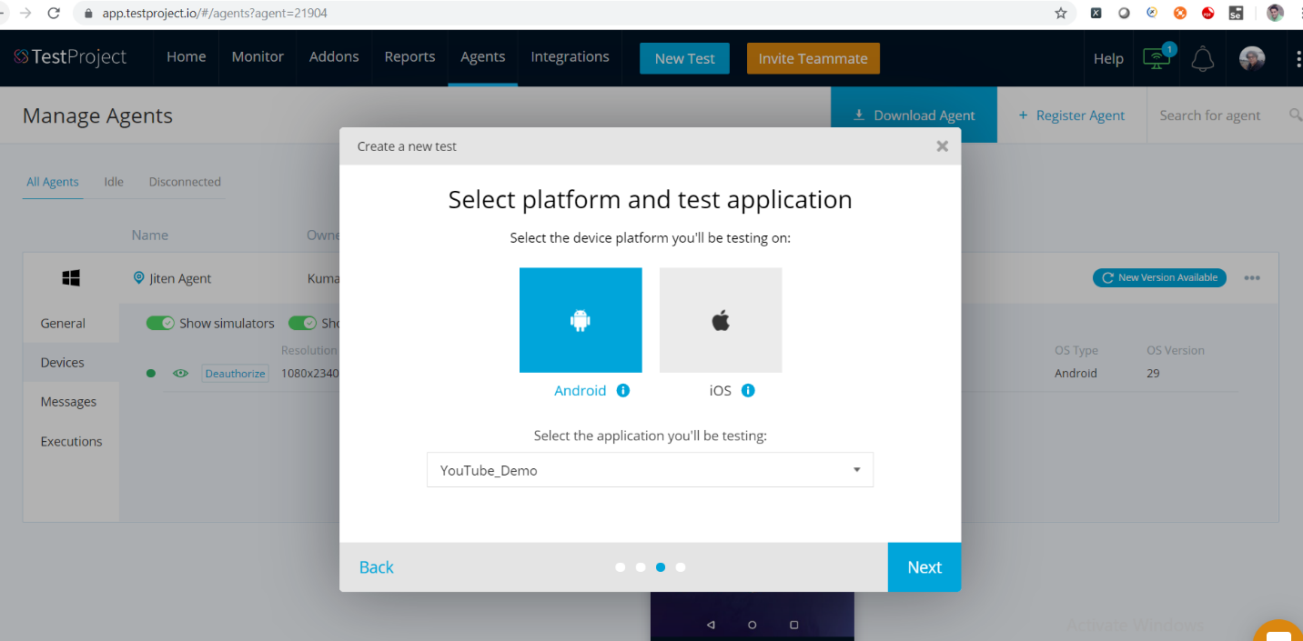

Click on record

Press double shift button

Create new job

Job created

Add test inside job

Open whatsapp

